**ANALYSIS REPORT ON EDGE LINE CALL CENTER**

**INTRODUCTION**

The dataset is for the analysis and reviewing of call data to identify trends and patterns. The dataset used in this analysis contains information about Call Id, Agent, date, Time, Topic, Answer, Resolved, Speed of Answer Per Second, Average Tallk Duration and Satisfaction Rating.

**ABOUT THE DATA/DATA COLLECTION**

This is a structured data and was given by Ganiyat Olajumoke Ajala. The data is a csv files which contains 5000 rows and 10 columns.

The analysis to be carried out is to answer the following question;

1. Who is the Agent with the most Resolved?
2. What is the most resolved Topic?
3. Who is the Agent with the highest Speed of Answer per Second?
4. Who is the Agent with the highest number of Satisfaction rating?
5. What is the total number of calls for each Topic?
6. What is the Average Talk Duration for Resolved calls?

**TOOLS**

The tool used is Microsoft Power BI for analysis and Power Query for data cleaning.

**DATA CLEANING AND TRANSFORMATION**

The following are the different cleaning procedures;

* The data contained nulls, but were not removed. The nulls were considered because some calls were not answered, therefore no value could be allocated to the cells with nulls.
* The time column data type was changed from “date and time” to “time” data type.
* The data value “Y” and “N” in the Answered column was replaced with “Yes” and No”.
* The data value “Y” and “N” in the Resolved column was replaced with “Yes” and No”.

**EXPLORATORY DATA ANALYSIS AND INSIGHT**

For the analysis to be understood and the questions answered, power bi visualization tools were used to effectively analyze for insights. Below are the analysis and insights for each questions.

1. **Who is the Agent with the most Resolved?**

To know the agent with highest number of resolved cases, the Agent and Resolved were filtered out. Analysis showed that agent Jim toped the chart with over 666 resolved issue; seconded by agent Martha with 638 resolved issues. Agent Stewart made it to the bottom of the chart with only 582 resolved issues.

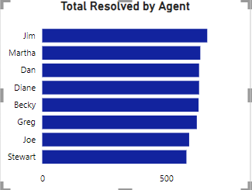

A stacked bar chart was used to show the number of resolved by agents.

1. **What is the most resolved Topic?**

The Resolved and Topic were filtered out in order to know which topic was mostly resolved by the agents. Analysis shows that the topic “Streaming” was largely resolved, as 749 resolved Streaming topic was recorded.

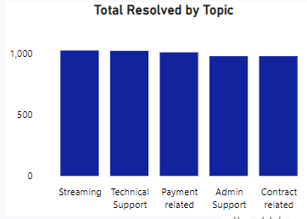

A stacked column was used to show the most resolved topic.

1. **Who is the Agent with the highest Speed of Answer per Second?**

In order to identify the agent with the highest speed of answer per second, “Agent” and the average “Speed of Answer Per Second” were filtered. Analysis deduced that agent Joe toped the chart with 70.99 average speed of answer per second.

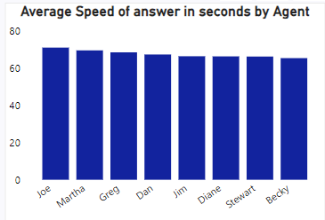

A stacked column chart was used to represent the average speed of answer in second by agent.

1. **Who is the Agent with the highest number of Satisfaction rating?**

The “Satisfaction” rating and “Agent” was filtered to know which agent has the highest number of satisfaction rating. After the analyzation of the data, with over 1819 points agent Jim had the highest number of satisfaction rating.

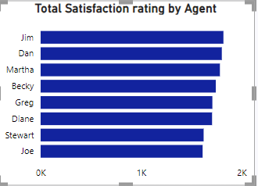

A stacked bar chart was used to represent the Satisfaction rating by Agent.

1. **What is the total number of calls for each Topic?**

To know the total number of calls for each topic, “Count of Topic” was filtered. Streaming had the total 1022 calls, Technical Support has 1019 calls, Payment Related has 1007 calls, Admin Support has 976 calls as well as Contract Related with total of 976 calls.

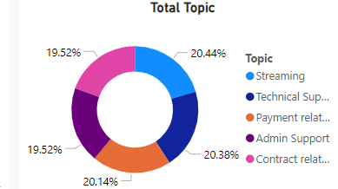

A donut chart was used to show the total calls per topic.

1. **What is the Average Talk Duration for Resolved calls?**

To know the total average talk duration for resolved calls, “Average Talk Duration” and “Resolved” were filtered. Analysis shows that the average talk duration for resolved calls is 391.

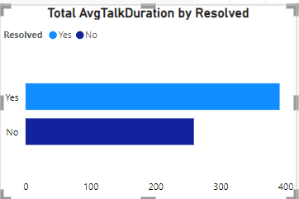

A stacked bar chart was used to show the Average Talk Duration by Resolved.

**RECOMMENDATION**

After carefully analyzing this data, I recommend that agent Becky, Stewart, and Diane put more effort by increasing the speed of answer per second of every call. Also, agent Stewart, Greg and Joe should work towards resolving 80-90% of customer issues; as this will help to improve the company’s satisfaction ratings and strengthen the trust and customer relationship.